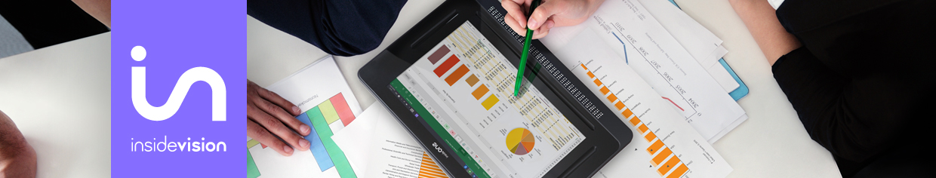

State Rehabilitation

insideONE the ultimate communication tool for professionals

Many of us, whether we use Braille in our schoolwork, on the job, or to promote independence in the activities of daily living, have always hoped that someday, we might have at our fingertips a powerful and portable integrated Windows Braille computer. And each time a new Braille device is announced, we keep hoping that this time, we will have a tool to promote the ultimate in literacy and self-reliance for visually impaired Braille users. With the introduction of the insideONE Windows 10 Braille Tablet, we now have that possibility.

The new, cool-feeling Windows 10 tactile tablet with an engraved braille keyboard built into the screen along with an integrated 32-cell braille display will take you anywhere you need to go, literally. This mainstream-looking tablet offers the freedom, and the opportunity, to become proficient in working independently with Braille, speech, and windows applications so you can excel at any educational, professional, or personal task.

Internet, email, Zoom, Chrome, and Dropbox are all there on your desktop, along with the trusted EasyReader application from Dolphin Systems Ltd. Whether you are a proficient Microsoft Office user or prefer a simpler, faster word processor such as Jarte, both are a click away. For the first time, 21st century computing that comes with integrated Braille is here, growing alongside and with you as you advance in your knowledge and competency.

There are no peripherals, no cables, no docking stations, and no braille displays that have to be connected or paired. What truly sets the insideONE tablet apart from all devices is that it allows, for the first time, a sighted and a blind user to see and feel what has been written or Brailled on the screen simultaneously.

Upon first holding this device, one rehabilitation professional said, "The hardware and braille display are pieces of art. The build quality is solid, the aluminum case is a delight to touch and hold, and the Braille is crisp, clear, and a pleasure to read. The movement of the pins is seamless."

Finally, and after so many years, the InsideONE braille computer is what Braille users who want to utilize Windows, along with their peers and colleagues, have been waiting for. All in a three-pound, easy to carry and rugged package, protected with a sturdy padded shoulder case. Truly, this is Braille, and computing power, with an attitude!

The InsideONE team brings together a collaboration of two companies, both owned and operated by blind professionals, that you have come to respect and trust: Mystic Access, and GuideLights and Gadgets, backed by the leading technology firm Insidevision, operating both in France and in the U. S. This is not a sighted company making and selling a product for the blind. The InsideONE undertaking is a truly unique collaborative process showing what blind-led training and development organizations backed by technology can bring to the marketplace.

What difference does this make? The tablet will come with both an in-depth machine-specific audio tutorial as well as a comprehensive Windows 10 audio tutorial geared toward Braille users, both created by Mystic Access. It comes with a set of tested blindness-friendly accessible applications. The InsideONE can instantly display a text translation of any braille typed on the screen for a sighted user and vice versa. You are empowered to choose the screen reader that does the job best for your clients. NVDA is the default screen reader, but JAWS also works interchangeably and seamlessly.

Talk to us about arranging a demonstration so we can show you the many ways that this tablet can be incorporated into the daily activities of your clients: at school, at work, at home, and for tasks and leisure activities, both big and small.

Contact us

For more information, please do not hesitate to contact a member of our team.

Mystic Access Team

chris@mysticaccess.com
kim@mysticaccess.com
phone: (716) 543-3323

GuideLights and Gadgets

bscheur@scheur.com
phone: 617-969-7500

Insidevision Inc.

igor.feinberg@insidevision-us.com
phone: 781-799-2971

